The Catcher in The Rye Pre-reading Webquest
Use the links that appear below each question to answer the questions.

1. Why would a book be banned/challenged?
http://libguides.butler.edu/bannedbooks?p=217686

The book would be barred if the opinion might be unpopular or unorthodox. The book will also be challenged if its writings contain racial issues encouraging racism towards a particular group of people. Besides, if the book encourages dangerous lifestyles, which may result in homosexuality and drugs, there are higher chances the book would be challenged. Books with content that includes the use of swear words and violence are usually conserved. Other reasons for banning a book includes political bias, religious affiliation, presence of witchcraft, and sexual situations ("LibGuides: Banned books: Reasons books are challenged," 2020).

2. Where was Catcher on the list in 2009?
http://www.ala.org/bbooks/frequentlychallengedbooks/top10

The book “The Catcher Rye” was in position six in the year 2009 as a result of unsuited to age group, sexually explicit, and the use of offensive language ("Top 10 most challenged books lists," 2020).

3. What are the reasons for Catcher being banned?
http://blogs.bl.uk/english-and-drama/2016/09/banned-from-the-classroom-censorship-and-the-catcher-in-the-rye.html

The book was canceled for several reasons, such as the use of 1950 teenage slang and abuse instances. Also, the book contains a majority of disturbing scenes, sexual content, and swearwords ("Banned from the classroom: Censorship and the catcher in the rye - English, and drama blog," n.d.).

4. Who was JD Salinger? Read his biography and summarize what you find below: http://en.wikipedia.org/wiki/J._D._Salinger

JD Salinger was a well-known writer of short stories such as “The Catcher Rye" and "The New Yorker."JD graduated from a series of colleges, including one where he met a professor who encouraged him to write and publish more work since the professor spotted Salinger's talent. After a short while, the writer served in the military for 2years as he continued with the book-writing work. However, his stories on “The Catcher Rye” book got negative reviews due to its content, which later led to its cancellation ("J. D. Salinger," 2001).

5. Catcher in the Rye is referred to throughout popular culture. List some of the music/tv/films in which it has been mentioned: http://en.wikipedia.org/wiki/The_Catcher_in_the_Rye_in_popular_culture

Some films that mentioned “The Catcher Rye” are the "good girl," "Chasing Holden," and "Conspiracy Theory." The tv show that mentions the novel is "south park," "the tale of scrotie of mcboogerballs," and "ghost in the shell: stand-alone complex." The books that mention “The Catcher Rye” in the novel are "the collector," "burglar in the eye," and "coming through the rye." Some music that mentions the book includes "we didn't start the fire" and "who wrote Holden Caulfield" (Catcher in the rye in popular culture," 2020)."

6. What was happening in the United States in the 1950s?
https://en.wikipedia.org/wiki/Timeline_of_United_States_history
Name two key political facts/events, and explain why they are significant to the time (and perhaps the novel).

A.Arrival of Native Americans
The arrival of the Native Americans constituted to the civilization of the indigenous communities

b. Civil war
The civil war forced technological advancement in warfare ("History of the United States," 2001).

7. Explore the fashion trends for men, women, and children during the 1950s. What do you notice? How does it differ from today's clothing?
http://www.fiftiesweb.com/fashion/fashion-w.htm
Women dresses were about a tailored look good grooming. Gloves and heels completed the look for women. For men, fuller suits were the main fashion. Their workplace choices of color were charcoal, blue, dark blue, and brown. Children's clothes include taped pants with shoestring ties, and cotton shirts were popular. The styles differ since people are influenced by known culture, popular television shows, and social media (the 1950s and 1960s Music, TV, History, Fashion, Slang, Cars,| FiftiesWeb, n.d.).

- Read about family life during the 1950s. What are some significant points? How do families today differ? http://www.fiftiesweb.com/pop/info-family.htm
The rich took their kids to prep schools while the poor depended on the public schools for educating their kids. Poor and ordinary families had little or no spare money for treats like holidays and cinema trips. Most families played board games since there were no computers (the 1950s and 1960s Music, TV, History, Fashion, Slang, Cars,| FiftiesWeb, n.d.).

9. Explore “prep schools” in the 1950s. What do you notice? http://www.ehow.com/info_7988082_prep-schools-1950s.html

The boys' higher number caused the boom in prep school attendance in 1950 .also most of the prep schools operated as boarding schools. Since the students lived miles away from the prep schools, the teachers believed boarding school would help build a boy's character. Besides, the institutes were not co-ed. Boys went to school intending to get into the finest universities while ladies went to school to become refined young females ("Prep schools in the 1950s," n.d.).

10. Attach images of the following:
- Map of New York in the 1950s and circle Central Park.
- Central Park merry-go-round
- Central Park Duck Pond
a) 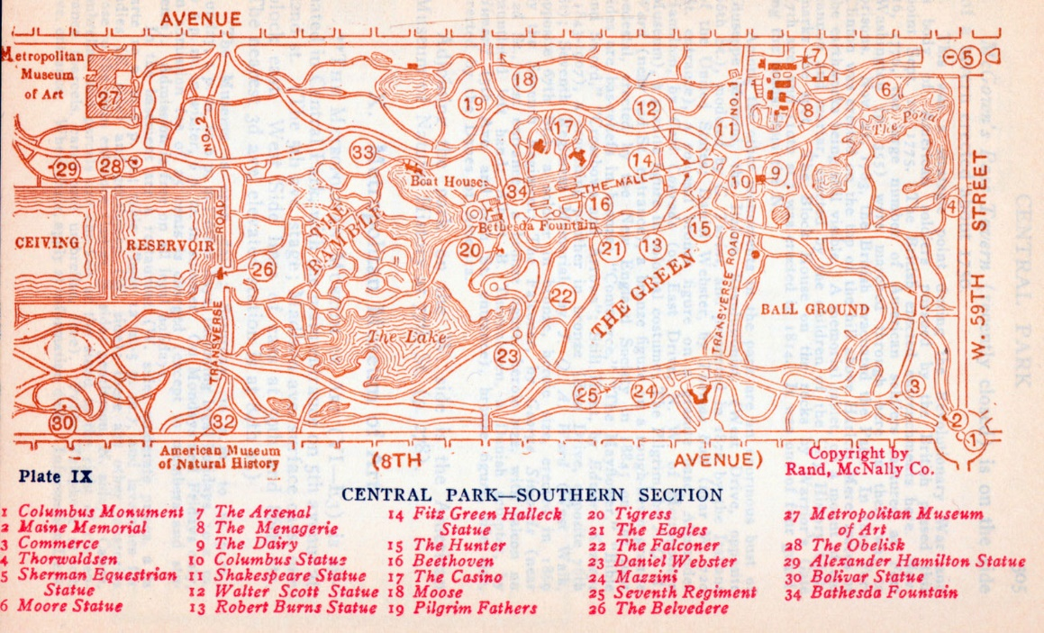

b) 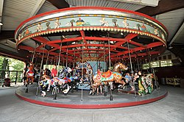

l

c) 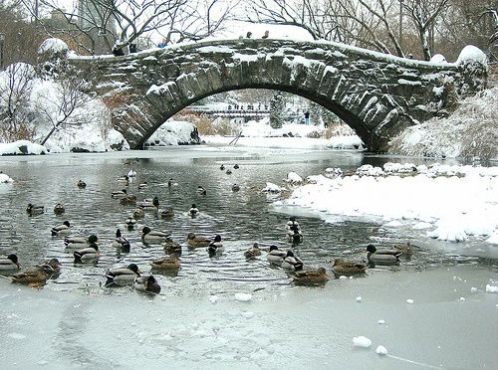

References
(n.d.). 1950s and 1960s Music, TV, History, Fashion, Slang, Cars,| FiftiesWeb. https://www.fiftiesweb.com/fashion/fashion-w.htm
(n.d.). 1950s and 1960s Music, TV, History, Fashion, Slang, Cars,| FiftiesWeb. https://www.fiftiesweb.com/pop/info-family.htm
(n.d.). 1950s and 1960s Music, TV, History, Fashion, Slang, Cars,| FiftiesWeb. https://www.fiftiesweb.com/pop/info-family.htm
Banned from the classroom: Censorship and the Catcher in the rye - English, and drama blog. (n.d.). American Collections blog. https://blogs.bl.uk/english-and-drama/2016/09/banned-from-the-classroom-censorship-and-the-catcher-in-the-rye.html
The Catcher in the rye in popular culture. (2020, October 4). Wikipedia, the free encyclopedia. Retrieved October 6, 2020, from https://en.wikipedia.org/wiki/The_Catcher_in_the_Rye_in_popular_culture
History of the United States. (2001, October 31). Wikipedia, the free encyclopedia. Retrieved October 6, 2020, from https://en.wikipedia.org/wiki/Timeline_of_United_States_history
J. D. Salinger. (2001, October 29). Wikipedia, the free encyclopedia. Retrieved October 6, 2020, from https://en.wikipedia.org/wiki/J._D._Salinger
LibGuides: Banned books: Reasons books are challenged. (2020, September 28). LibGuides at Butler University. https://libguides.butler.edu/bannedbooks?p=217686
Prep schools in the 1950s. (n.d.). https://www.ehow.com/info_7988082_prep-schools-1950s.html
Top 10 most challenged books lists. (2020, April 20). Advocacy, Legislation & Issues. https://www.ala.org/bbooks/frequentlychallengedbooks/top10

